Writing her own Script. Women Photographers from the Hyman Collection
Curated by The Centre for British Photography

Photo London 2023
11 - 14 May 2023, Somerset House www.photolondon.org
Eliza Hatch, Florence, 2017. C-Type colour print. © Eliza Hatch

Photo London is pleased to present ‘Writing her own Script. Women Photographers from the Hyman Collection’ as part of the 2023 Public Programme. Alongside a solo show of new work by this year’s Master of Photography Martin Parr, the exhibition is a timely celebration of the best of British photography.

‘Writing her own Script’ celebrates many of the pioneering women photographers at work in Britain over the last 100 years. It charts a course from the 1930s to the present and provides an

overview of photography in Britain that focuses on two strands: a humanistic documentary tradition and a more personal, performative, practice. The exhibition takes its name from a large-scale photograph by Susan Hiller.

It begins with political and social engagement, presenting the very rare work of Edith Tudor-Hart, the Picture Post photographs of Grace Robertson, the street photography of
Dorothy Bohm and the humanism of Shirley Baker and Marketa Luskacova. It then suggests the importance of this legacy to younger photographers that include Eliza Hatch and Bindi Vora. It aims to provide an opportunity to consider the use of photography as a social or political tool.

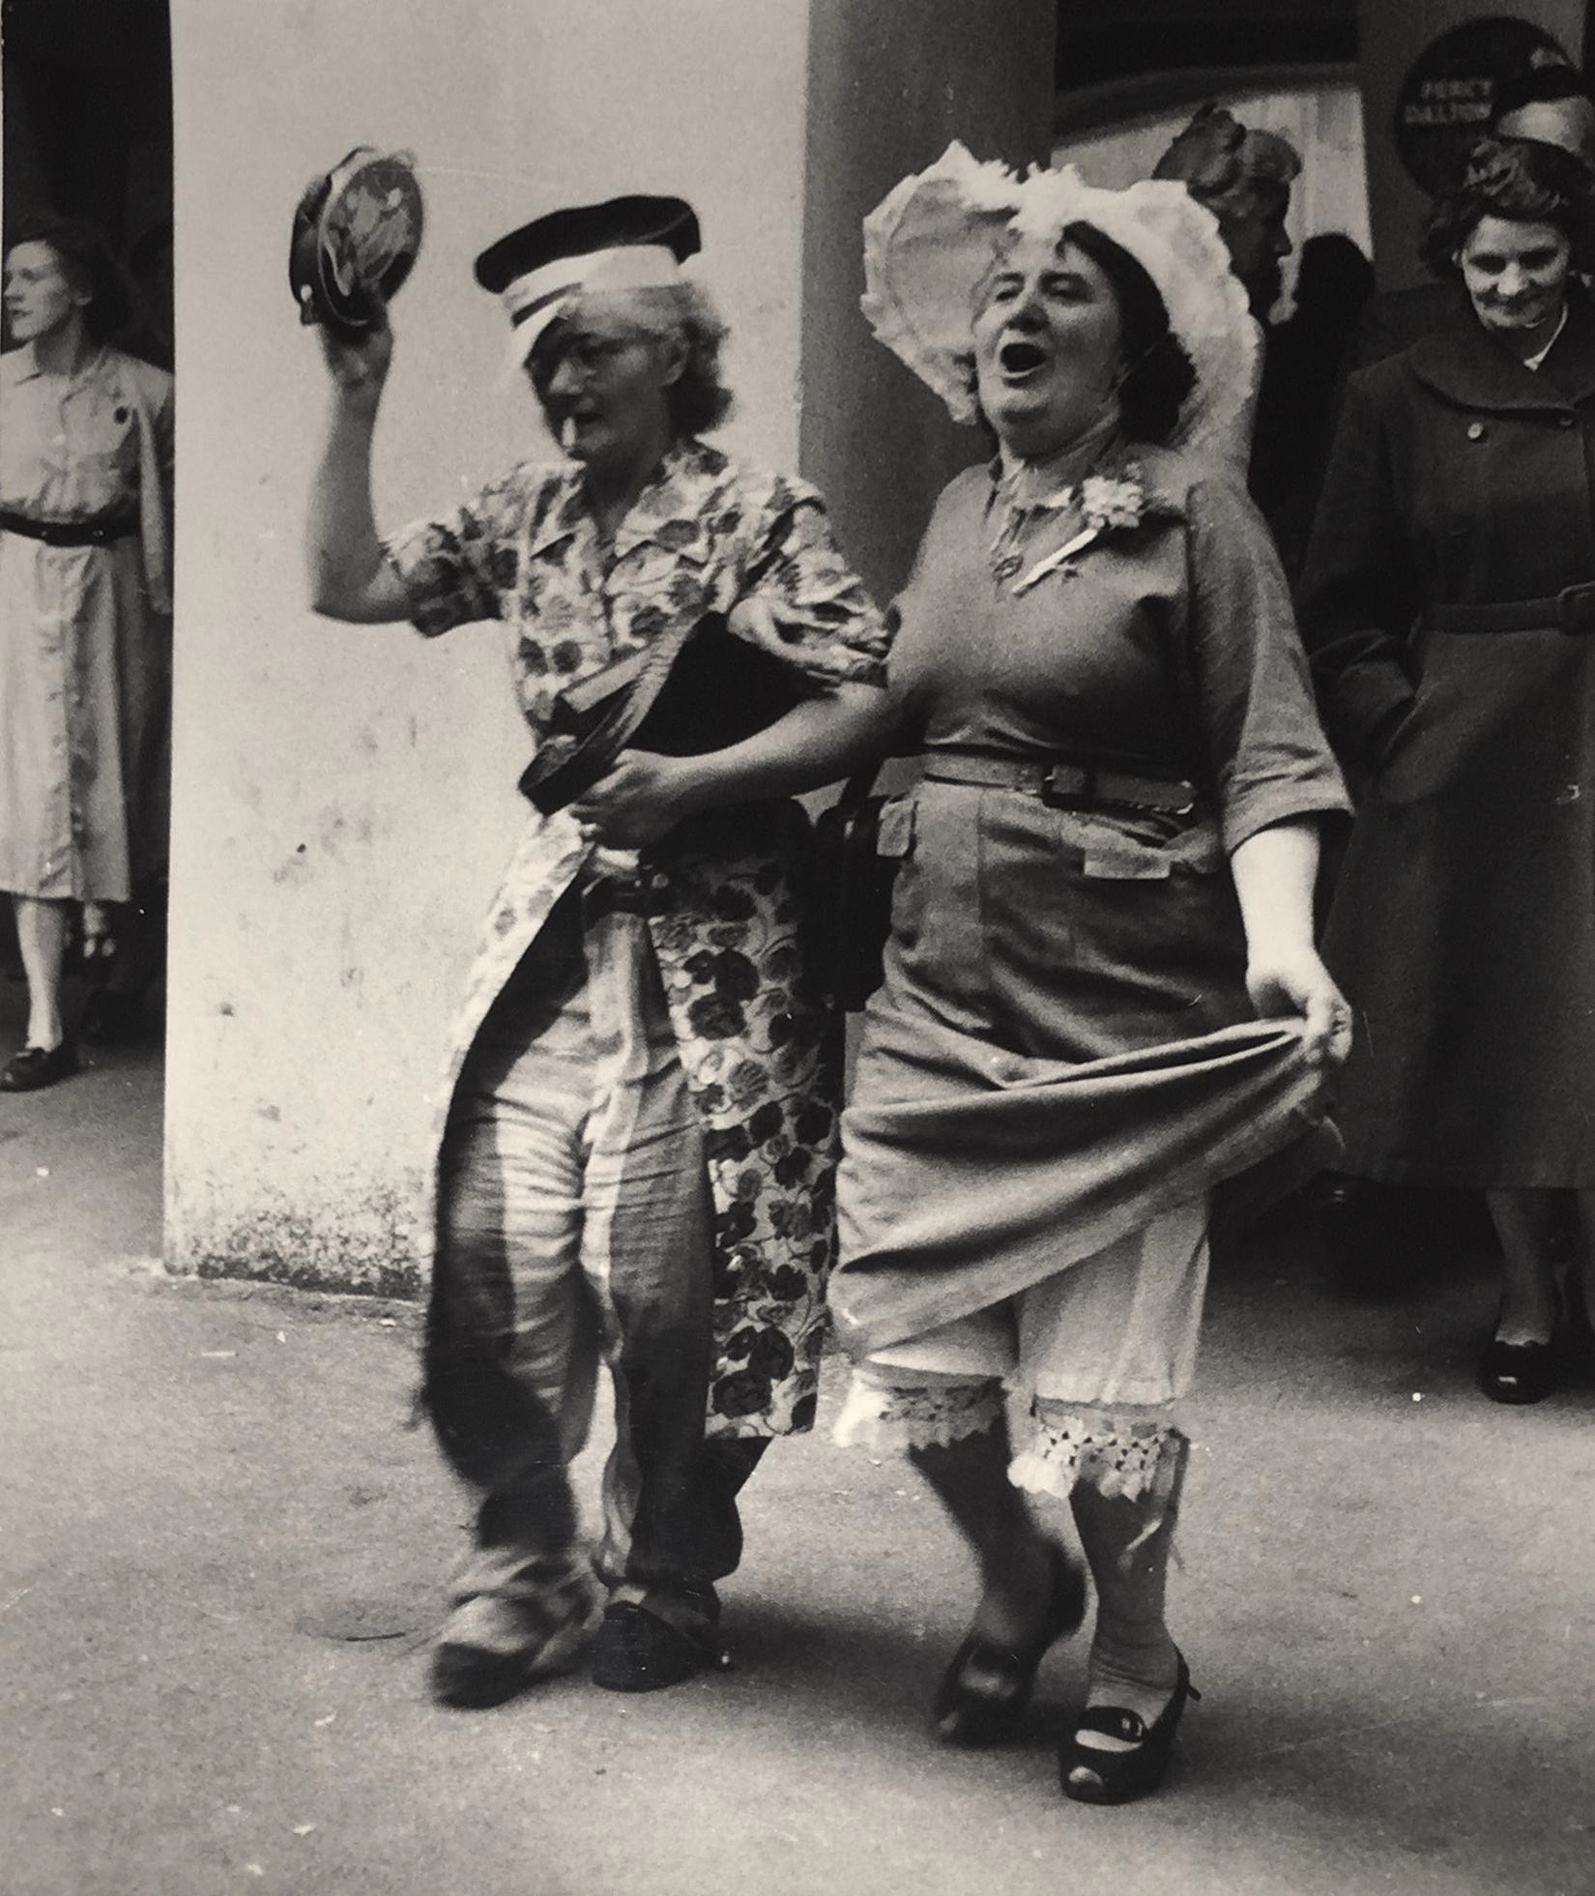
The exhibition then focuses on the pioneering feminist work of Jo Spence, Alexis Hunter, Susan Hiller and Sonia Boyce and their exploration of psychological and physical wellbeing. In doing so it aims to de-stigmatise subjects around mental health and create an environment in which people can have open conversations about their wellbeing. This section will include the photo-therapy of Rosy Martin, powerful portraits by Anna Fox, and the self-portrait based works of Heather Agyepong, Juno Calypso, Rose-Finn Kelcey and Polly Penrose.
Grace Robertson, Pub Outing, 1954. Courtesy of The Hyman Collection

The exhibition includes work by Heather Agyepong, Shirley Baker, Dorothy Bohm, Sonia Boyce, Juno Calypso, Helen Chadwick, Hannah Collins, Caroline Coon, Maisie Cousins, Rose Finn-Kelcey, Anna Fox, Eliza Hatch, Susan Hiller, Alexis Hunter, Sarah Jones, Karen Knorr, Marketa Luskacova, Sarah Maple, Rosy Martin, Linda McCartney, Laura Pannack, Polly Penrose, Grace Robertson, Jo Spence, Edith Tudor-Hart and Bindi Vora.

James Hyman, Founding Director, Centre for British Photography, comments: “Following the recent opening of the Centre for British Photography, we are delighted to have this opportunity to present an exhibition of works from the Hyman Collection and to spread the word about our activities. For many years we have been committed to supporting women working in photography, so we were pleased to be asked by Photo London to curate an exhibition that focuses on this important aspect of the collection.”

Photo London’s Founders Michael Benson and Fariba Farshad comment: “Since the outset when we began with a major courtyard installation by Rut Blees Luxemburg, we have championed the role of women in photography. The number of women taking part in the Fair has risen steadily to the point where 70% of the artists, curators and gallerists are female. So, we are delighted to spotlight women in photography through this exhibition which offers an important look at the achievements and influence of the female practitioners who have transformed the photographic landscape in Britain over the past century.”

For further information about Photo London 2023 and to book tickets, please visit: https://photolondon.org/

PRESS CONTACTS

Photo London PR representative Pickles PR: Gair Burton E: gair@picklespr.com or Christina Almeida E: christina@picklespr.com

Relations Media, Catherine Philippot, PR representative for France E: cathphilippot@relations-media.com

